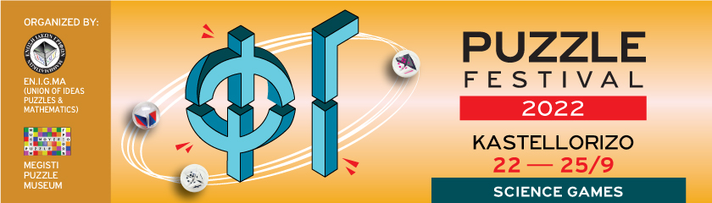

Press Release

2nd Kastellorizo Puzzle Festival, 15 days before its start (22-25/9/22)

And the wish... became reality!!!!

Last year's Puzzle Festival ended with the wish: to become an institution and for the island to even export its own culture.... So Science once again sets sail full speed for Kastellorizo, the small picturesque island at the easternmost tip of Europe with such a special historical, cultural and geographical physiognomy. It has impressive architecture, important ancient monuments, endemic flora and fauna, beautiful nature and countless paths. An island where, from the Neolithic Age to the present day, important civilizations of mankind had met. In fact, the official name of the island is Megisti, apparently due to its larger size compared to the island complex that surrounds it.

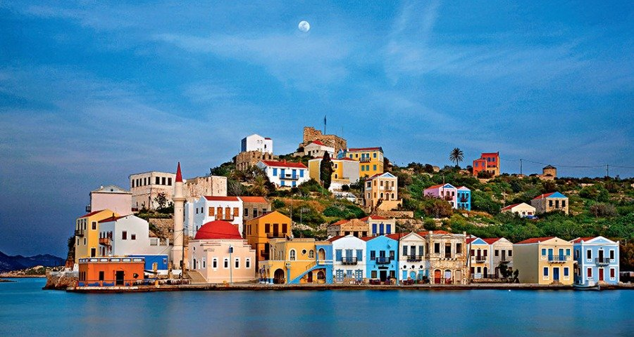
A great effort, an important idea is approaching again this year towards its realization, with many and greater expectations. Our main goal is for scientific knowledge to reach everyone – young and old – in a simple, accessible, interactive and enjoyable way. Ambitious, expanded program with innovative actions, some of which will be included in the morning program of the school on 22 and 23/9, programs approved by the Ministry of Education, that approach knowledge "subversively" (Cinemathesis, Ready... Motor.. Go, Values travel –EU project VAST, Play and Learn –TEPAES/University of the Aegean).

Also, the well-known Humanitarian Civil Society Organization “Kids Save Lives” will give first aid/rescue lessons and will install an external defibrillator (courtesy of the company VIORYL).

There will be no speeches of academic style, but simple discussions, scientific events in the form of a game or theatrical narrative, impressive experiments, STEM, tours, treasure hunt, Stand up Science for children, exhibitions, film / music workshops and especially countless puzzles that will persistently ask for their solution.

Indicatively, we mention only some of the numerous activities:

- The mathematician and Founder of the Puzzle Museum, Pantazis Houlis, will highlight the importance of the puzzles, the history of the island and its beauties by walking the paths of the island that he himself carved out
- Michail Toulouzas, a multi award-winning puzzle maker, will present samples of his award-winning puzzles.
- There is some international recognition for the festival as we have the honor to introduce the American collector and puzzle designer Bob Hearn.
- A constant value and highlight of the festival, is the professor of the University of Crete Michael Lambrou, who will approach mathematics through entertaining narratives and mathematical tricks.
- There will be live connection with CERN and guide Dr. Theodoros Geralis, Research Director, Institute of Nuclear and Particle Physics of NCSR Demokritos, who participates, as a researcher of "Delta', in the ATLAS experiment of the LHC."
- Kosmas Gazeas, astrophysicist (NKUA) will invite us to touch the planets and wander mentally in our solar system through his interactive exhibition Planets In Your Hand.

- Impressive astro/sun observations: through telescopes and lasers we will get to know the starry sky and our solar system. (Cooperation between the National and Kapodistrian University of Athens and the Athens Observatory)
- Unexpected navigations and surprises from the Patras "Crew 94"
- Researchers from the Pasteur Institute, the Foundation for Research and Technology, the Athena/ILSP Research Center, the University of the Aegean. SHP etc. they will spark interest by "playing" with the curiosity of the public on issues of their scientific area.
- The scientific festival will close with the unique sisters Eleni and Suzana Vougioukli with their wonderful vocal timbres!!

For more information please visit the site: https://kastellorizofestival.com
To contact us:

Pantazis Houlis: Organizer/ Megisti Puzzle Museum
e-mail: pandahou@yahoo.com – T +30 22460 49454 & +30 6980865814

Eleni Grammatikopoulou: Co-Organizer/Science Communication
e-mail: eleni.gramma@gmail.com - T. +30 2106395458 & +30 697 4228637

